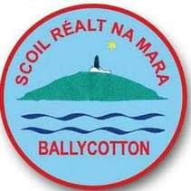

Scoil Réalt na Mara N.S.
ANNUAL ADMISSION NOTICE
in respect of admissions to the 2022/2023 school year

Admission Policy and Application Form
A copy of the school’s Admission Policy and the Application Form for Admission for the Scoil Réalt na Mara N.S. is available as follows: –
To download at: www.scoilrealtnamara.ie
On request: By emailing secretary@scoilrealtnamara.ie or writing to Scoil Réalt na Mara N.S., Ballycotton, Midleton, Co. Cork. P25RX22

PART 1 - Admissions to the 2021/2022 school year

Application and Decision Dates for admission to Scoil Réalt na Mara N.S.
The following are the dates applicable for admission to Junior Infants

The school will commence accepting applications for admission on | 10 December 2021
The school shall cease accepting applications for admission on | 7 January 2022
The date by which applicants will be notified of the decision on their application is | 28 January 2022
The period within which applicants must confirm acceptance of an offer of admission is | 18 February 2022

Note: the school will consider and issue decisions on late applications in accordance with the school’s admission policy.

Number of places being made available in Scoil Realt na Mara N.S.

The number of places being made available in junior infants is | 18

